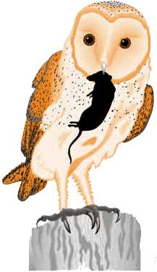
Before you can start your actual owl pellet dissection you must first complete the virtual dissection.
Go to http://www.kidwings.com/owlpellets/flash/v4/index.htm
Click on pellet information and answer the following questions:
- What is a pellet?

- How do pellets form?

- What is inside a pellet?

- Why are pellets important?

Before you can start your actual owl pellet dissection you must first complete the virtual dissection.
Go to http://www.kidwings.com/owlpellets/flash/v4/index.htm
Click on pellet information and answer the following questions:
- What is a pellet?

- How do pellets form?

- What is inside a pellet?

- Why are pellets important?

