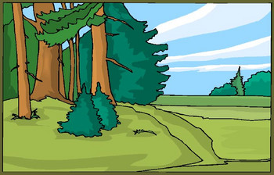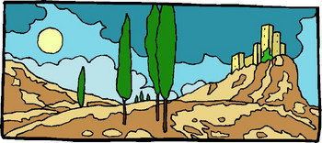

## BIOMES!!!

**Name(s)** _____________________________________________________________

**Biome** _________________________________

In groups of 1-2, you will research a major biome on the Earth (desert, tundra, taiga, Riparian woodland, oak woodland, temperate rain forest, freshwater marsh/bog, saltwater wetland, deciduous forest, tropical rain forest, & prairie), prepare a detailed description for your biome. You will also need to find out how humans have affected your biome. With this project you are not only presenting your biome, but you are also going to be able to explain some fancy ecology concepts with this project.

# Finished Product:

You will be using PREZI or VUVOX to create your project, NO PPT. You will want to divvy up the parts you will need to include in your presentation. *No one person should be creating all of the PowerPoint slides*. You must include the following:

1. **Background on Biome**

* Show where it is found around the world (use a map & names of locations)
* General description of your biome

1. **Abiotic Factors of Biome**

* Climate: Show a climatogram (The average monthly precipitation & temperature for 1 year)
* Soil profile: Find the type of soil found in your biome (you may not be able to find this online & will need to draw and label a picture you create)
* List any non-renewable or renewable resources in your biome

1. **Biotic Factors of Biome:**

* List common plants found in biome (at least 5)
* List common animals found in biome (at least 5)
* Make a food web using these lists.
* Give specific examples of mutualism, commensalism, parasitism, & competition within your biome.

1. **Human Influence on Biome:**

* Include any environmental damage done to ecosystem by humans & any solutions that are occurring to protect/save your biome.
* List any National Parks &/or Monuments found in your biome
* List any losses of biodiversity (species) in your biome & the effects that has had

1. **Sources**

* Be sure to cite where your information came from & any images you used from the internet.

Here are some sites to get you started below:

**Websites**

http://www.ucmp.berkeley.edu/glossary/gloss5/biome/

http://www.worldbiomes.com/biomes_map.htm

http://www.worldbiomes.com/

|  |  |  |
| --- | --- | --- |
| **BIOME Presentation Rubric**  Your Name(s) _______________________________________________________  Biome _________________________ | | |
| **Criteria** | **Points Available** | **Points Achieved** |
| **Background on Biome**   * Description of biome * Where it is found around the world (use a map & names of locations) * General description of your biome | **15** |  |
| **Abiotic Factors of Biome**   * Climate: Show a climatogram (The average monthly precipitation & temperature for 1 year) * Soil profile: Find the type of soil found in your biome (you may not be able to find this online & will need to draw and label a picture you create) * List any non-renewable or renewable resources in biome | **20** |  |
| **Biotic Factors of Biome:**   * List common plants found in biome * List common animals found in biome * Make a food web using these lists. * Show the energy pyramid using these lists. * Give specific examples of mutualism, commensalism, parasitism, & competition within your biome. | **25** |  |
| **Human Influence on Biome:**   * Any environmental damage done to ecosystem by humans & any solutions that are occurring to protect/save biome * Any National Parks &/or Monuments found in biome * Any losses of biodiversity (species) in biome & the effects that has had | **20** |  |
| **Images/Photos:**   * Used images &/or photos to explain info about biome | **10** |  |
| **Sources:**   * List any websites visited &/or used * Cite any images used | **10** |  |
|  | **100 pts possible** | **TOTAL SCORE:** |
| **Comments:** | | |