Stetson Hills Seventh Grade Supply List

The following supplies will help ensure your student's success in 7th grade. Thank you for your support in providing these materials.

Academic Supplies:
We use interactive student notebooks in each Core class, the following supplies are used weekly in each class.

5 folders 1 folder per class
4 notebooks One-Subject spiral notebook per class
8 glue sticks (2 per quarter at least)
Pencils
Pens—any color (a must-have for everyday in Math)
1--Highlighter (Any color)
1--Box colored pencils with hand-sharpener
Loose Leaf Paper
One set of whiteboard markers
Whiteboard eraser

Suggested Items:
*Flash drive
*Email address (you can sign your child up for a free account at gmail.com)
*Vuvox account (sign up for a free account at Vuvox.com)
*Prezi account (sign up for a free account at Prezi.com)
*Mixbook account (sign up for a free account at Mixbook.com)

Classroom donations Thank you!!
Facial tissue
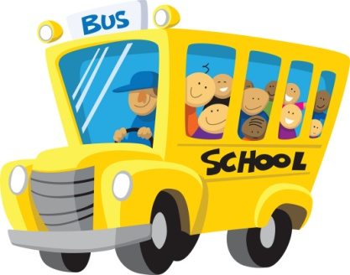Paper Towels
Baby wipes or disinfectant wipes
Hand sanitizer (for flu season)
Colored Xerox paper (for foldables)

Science Lab Donations
Flour
Nesquick(or other chocolate powder)
Styrofoam bowls
Ziplock bags- of all sizes
Spaghetti
Tin Foil
Popsicle Sticks
Marshmallows
Empty 2-liter bottles
Clean empty tuna cans

**Arizona law requires that public schools provide supplies required for academic success. Teachers may request optional, supplementary items, which you may supply at your discretion. If you have any questions, please feel free to contact the school office.

